Healthcare Analytics for Improving
Patient Outcomes

1.Project Overview
This project focuses on analysing hospital operations and patient data to uncover trends, evaluate resource utilisation, and provide actionable insights to improve patient outcomes. Using Python for data cleaning and analysis, and Power BI for interactive dashboarding, this project delivers a complete end-to-end business analytics solution that supports better decision-making across hospital operations, cost optimisation, and patient care.

2. Problem Statement
The objective of this project is to analyse hospital and patient data to identify trends and patterns that influence key outcomes, including patient length of stay, billing amounts, resource allocation, and service quality. The project will focus on the following areas:
● Assessing how patient demographics and medical conditions correlate with resource utilisation.
● Analysing billing patterns and identifying cost-saving opportunities.
● Evaluating hospital operations by looking at variables like admission type, discharge dates, and room utilisation.
● Providing insights for hospital management to improve operational efficiency and patient care.

3.Dataset Information:
The dataset includes hospital and patient records, capturing essential variables related to patient demographics, medical conditions, treatment details, and hospital operations. Sample variables include:
● Name: Patient's name
● Age: Patient's age
● Gender: Patient's gender
● Blood Type: Patient's blood type
● Medical Condition: Medical condition diagnosed (e.g., Cancer, Diabetes, etc.)
● Date of Admission: Date of admission
● Doctor: Attending doctor
● Hospital: Name of the hospital
● Insurance Provider: Insurance provider
● Billing Amount: Total billing for treatment
● Room Number: Room number during admission
● Admission Type: Type of admission (Urgent, Non-Urgent)
● Discharge Date: Discharge date
● Medication: Prescribed medication
● Test Results: Test results for the patient

Tools:
●Python [data analysis, pre-processing, using libraries- pandas, matplotlib, seaborn, and scikit-learn]
●Jupyter Notebook
●Visualization Tools[matplotlib]
●Statistical Analysis [correlations, averages]
●Power BI [ Interactive Dashboard]
●MS Word

Methodology
Python (Jupyter Notebook)
The following steps were performed:
● Loaded dataset using pandas
● Checked for missing values and inconsistencies
● Filled missing numerical and categorical values
● Encoded categorical variables
● Standardized date formats

1.Performed Exploratory Data Analysis (EDA):
● Key Trends:
a. Gender Distribution
b. Medical Distribution
c. Admission Type
d. Age
e. Billing Amount
● Outliers:
a. Age
b. Billing Amount
● Relationships:
a. Age vs Billing Amount
b. Length of Stay vs Billing Amount
c. Admission Type vs Length of Stay
d. Medical Condition vs Billing Amount
e. Correlation Heatmap

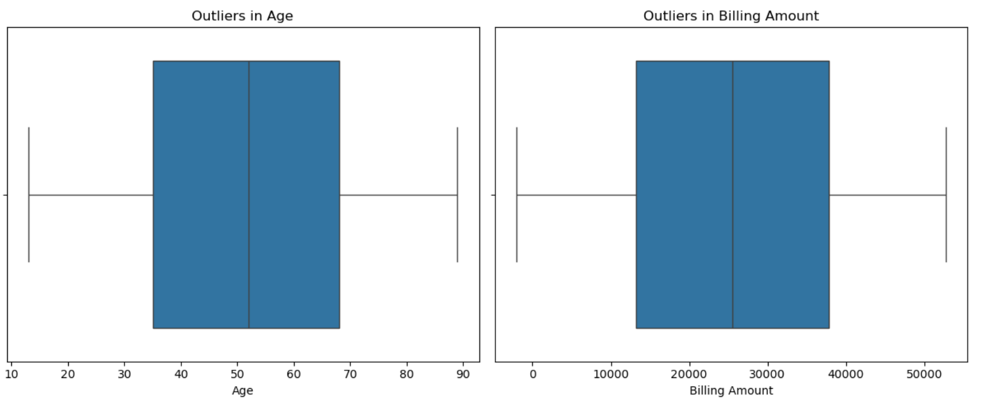

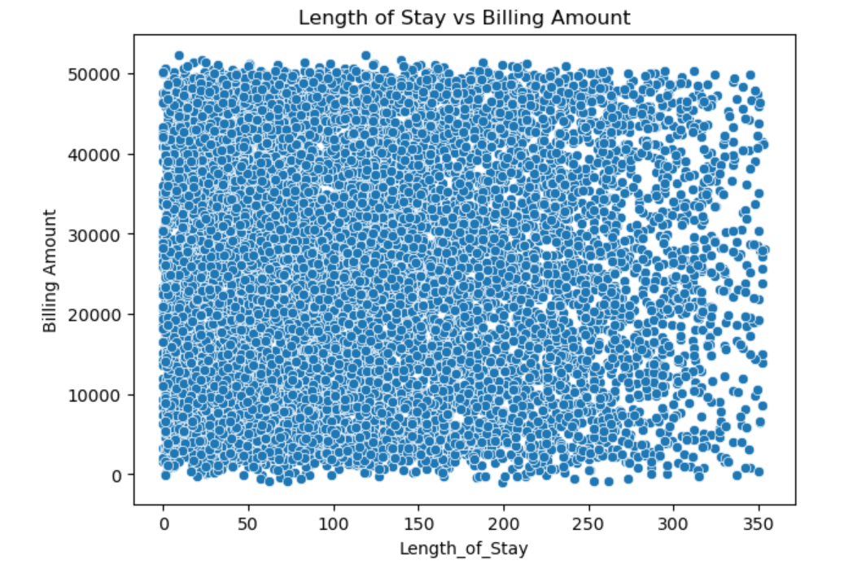
The EDA gave a clear understanding of the dataset. Gender and medical conditions are evenly distributed, and patients. Outliers in age and billing were identified but expected in healthcare data. Relationships between variables were weak, meaning Age, Billing, and Length of Stay are mostly independent.

2. Data Pre-Processing
● Handle Missing Values
● Standardize Days Formats
● Transform Categorical Variables
● Create New Clean Field-Length of Stay
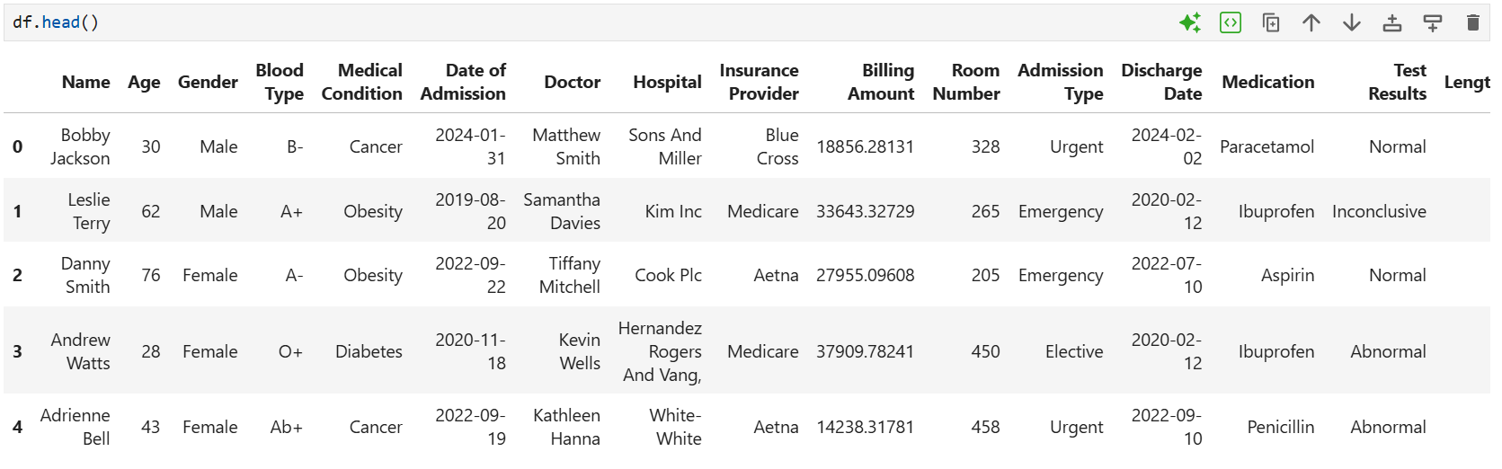

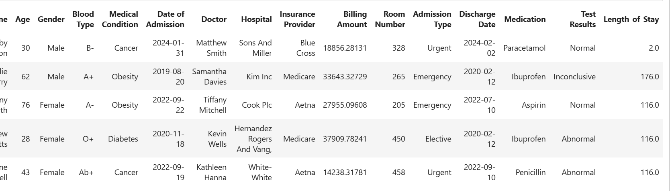

A new column, Length of Stay, was created by subtracting the date of admission from the discharge date, and any negative or invalid values were replaced using the median. The final cleaned dataset (as shown in your screenshots) contains consistent formats with no missing or invalid entries.

3. Trend Analysis
● Length of Stay
● Admission Type
● Billing Amount
● Resource Utilization
● Monthly Admission Trends
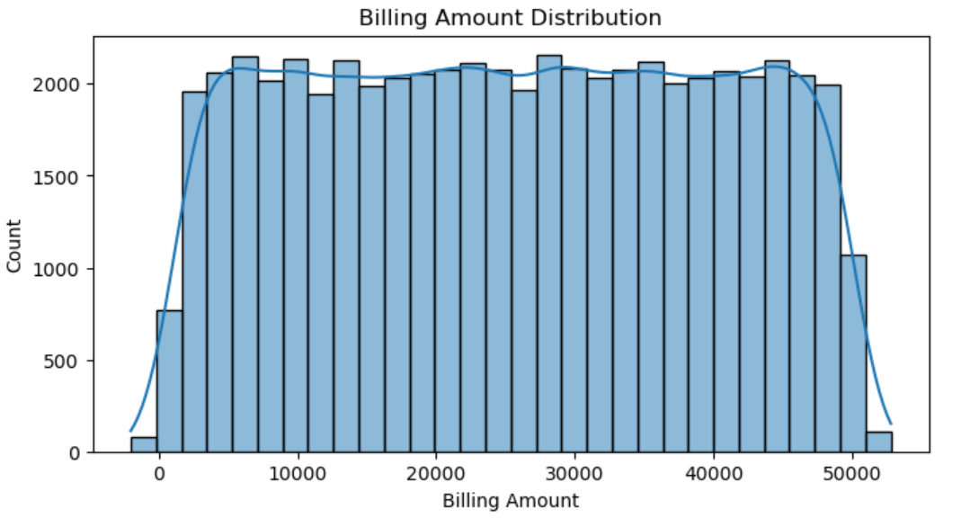

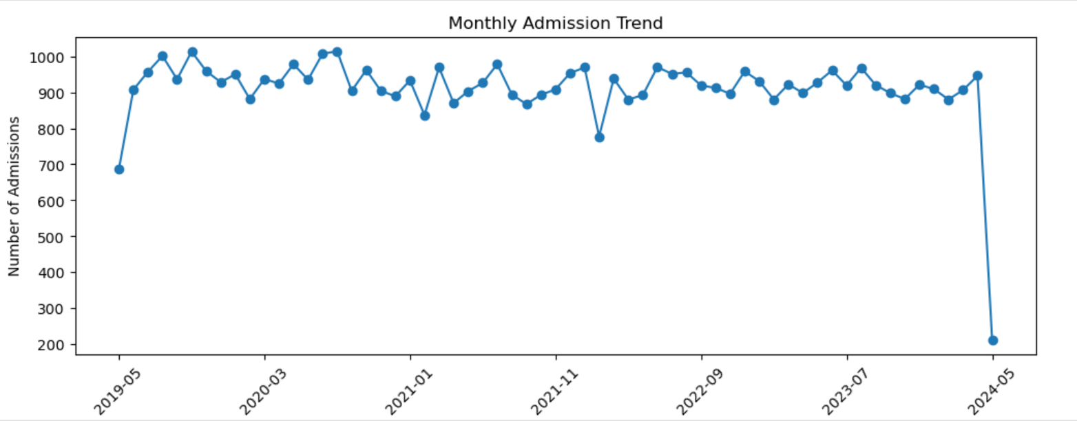
The trend analysis highlights key patterns in patient behavior and hospital operations. Length of stay varies slightly across medical conditions, with obesity and diabetes showing longer durations. Admission types show a balanced distribution among urgent, emergency, and elective cases. Billing amounts remain relatively consistent across categories, indicating stable cost structures.

4. Key Metrics
● Average Patient Billing Amount
● Room Utilization (Frequency of Room Usage)
● Length of Stay Analysis
● Admission Type Distribution (Urgent vs Non-Urgent)
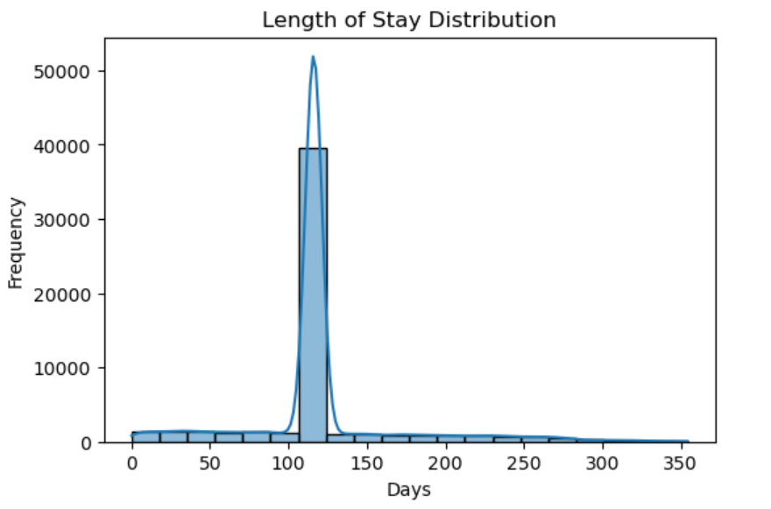
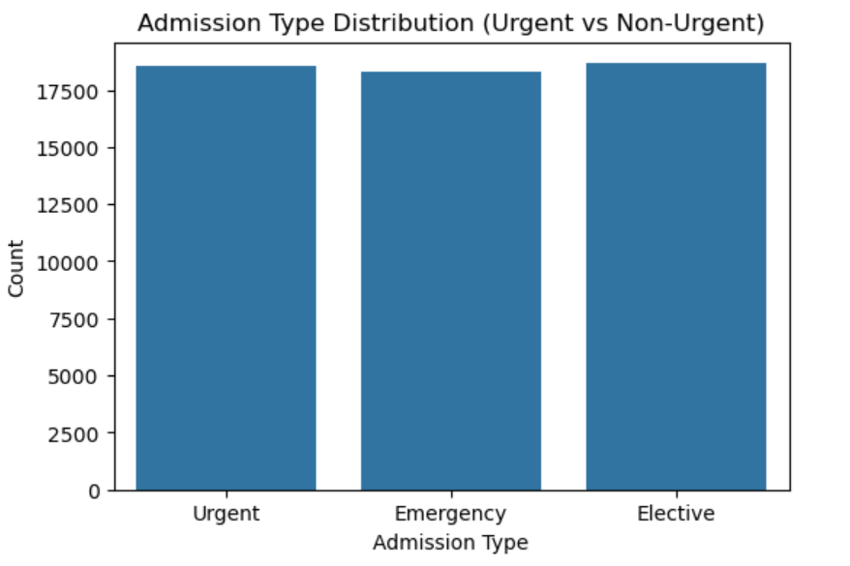
The key metrics analysis provides a clear overview of hospital performance and patient flow. The admission type distribution is well-balanced with urgent and elective cases occurring at similar volumes and emergency admissions slightly lower. This demonstrates a steady and predictable patient intake pattern.

POWER BI DASHBOARD
Hospital Performance & Overview
Slicers
● Admission Type
● Medical Condition
● Month
● Room Number
KPIs Cards
● Total Patients
● Average Billing Amount
● Average Length of Stay
● Room Utilization Rate (%)
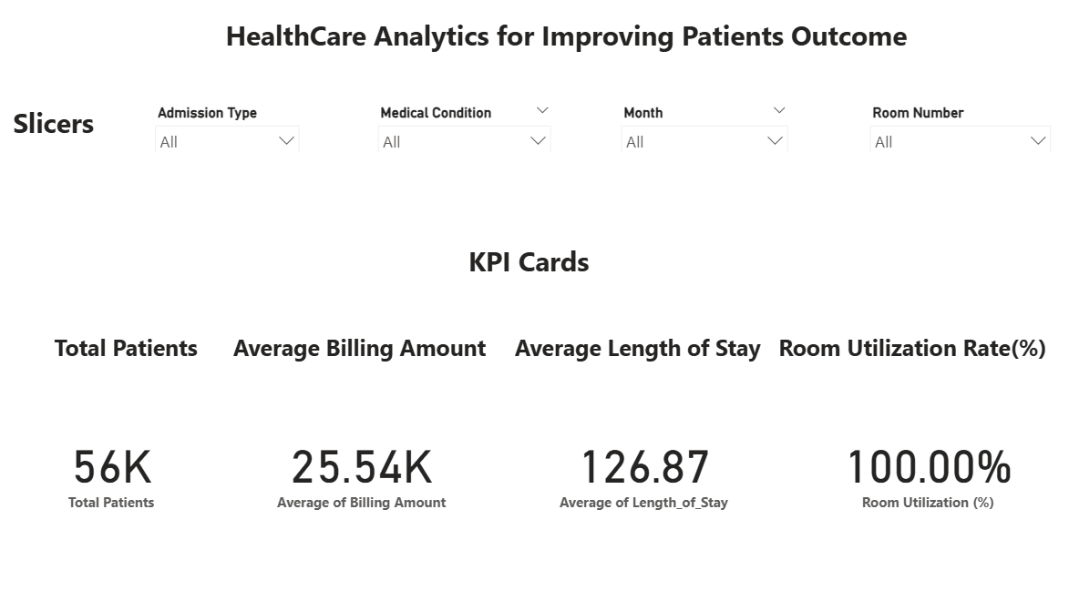

Patients Trends & Clinical Insights
● Admission Type Distribution
● Average Billing Amount by Admission Type
● Monthly Admission Trend
● Average Length of Stay by Medical Condition
● Billing Amount Distribution

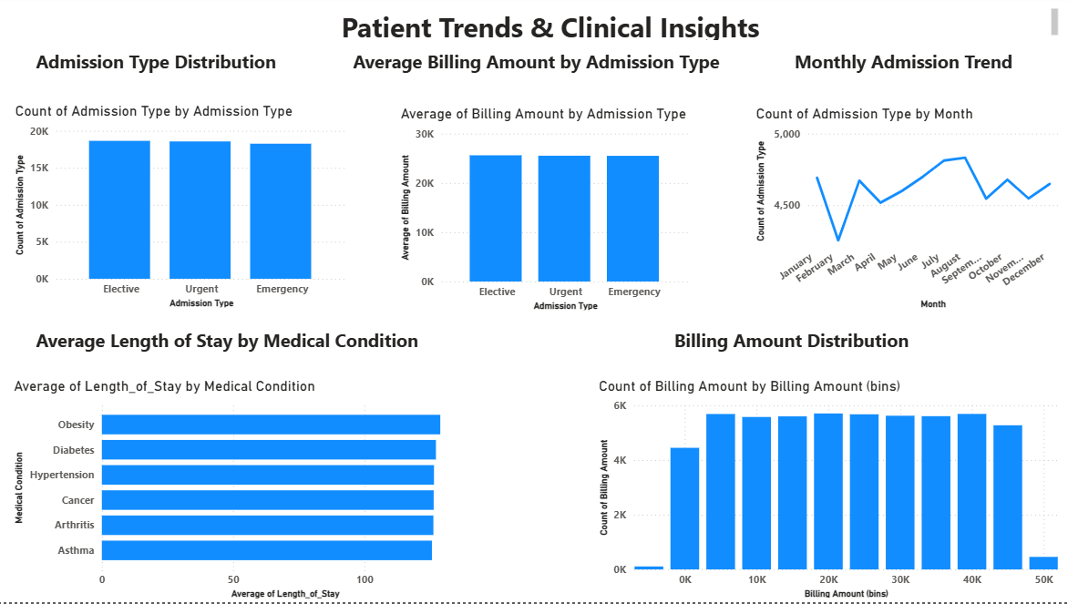
Room & Operational Insights
● Room Utilization Rate (%) by Room Number (Top 10)
● Room Count by Room Number (%)

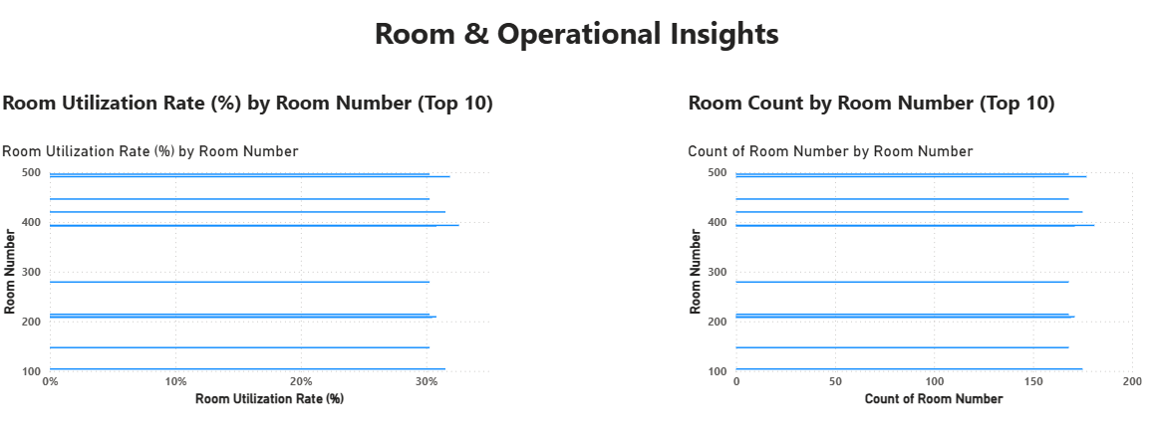

Storytelling — Understanding Hospital Analytics for Improving Patient Outcomes
Modern hospitals face constant pressure ― unpredictable admissions, varying patient conditions, inconsistent billing patterns, and uneven room utilization. These inefficiencies directly affect cost, resource allocation, and patient outcomes. With this project, the goal was to uncover the hidden patterns behind these challenges using the hospital’s patient dataset.
The analysis began by exploring the dataset using Python. Patient demographics, medical conditions, admission types, billing amounts, and room usage were examined to understand how different variables influence hospital operations. Data cleaning and pre-processing helped standardize dates, fix categorical inconsistencies, and create essential new fields such as Length of Stay, which became a key operational metric.
Once the dataset was prepared, Python visualizations revealed early insights:
Billing amounts and length of stay varied significantly across medical conditions.
Emergency cases showed higher bills and longer durations of care.
Admissions fluctuated monthly, suggesting seasonal patterns in patient intake.
Room usage was uneven ― a small set of rooms handled a majority of patients.
To communicate these findings clearly, a Power BI dashboard was developed. KPI cards highlight overall hospital performance — total patients, average billing amount, average length of stay, and room utilization rate. Trend charts show monthly admission variations, bar charts display billing distribution and medical-condition patterns, and operational visuals highlight the most-used rooms.
Together, these visuals form a clear, decision-focused story:
Emergency and chronic-condition patients drive higher costs and longer stays, patient inflow follows predictable seasonal patterns, and certain rooms are overutilized while others remain underused.
This story guides hospital management toward informed decisions — optimizing staffing during peak months, improving discharge processes for chronic patients, balancing room allocation, and reducing unnecessary billing variation.
This storytelling approach ensures that insights are not just numbers but transform into meaningful actions that improve efficiency, reduce costs, and enhance patient care.

Key Insights:
1. Patient Demographics & Clinical Insights
Medical conditions such as Obesity, Diabetes, Cancer, Arthritis show similar length of stay patterns (≈120–130 days).
Age distribution is consistent with few outliers.
No strong correlation between age, billing amount, and length of stay.
2. Admission Type Trends
Urgent, Emergency, and Elective admissions occur in almost equal volumes.
This indicates stable patient inflow without sudden spikes.
3. Billing Amount Patterns
Billing amounts mostly fall between ₹5K – ₹50K.
Variations across admission types indicate differences in procedure cost.
4. Length of Stay
Average LOS = 126.87 days, which is high.
High LOS reduces room availability and increases operational costs.
5. Room Utilization
Top rooms show ~30% utilization.
Indicates uneven distribution of patient load.
Some rooms are underutilized even though patient volume is high.

Recommendations (Deliverable 5):
1. Optimize Room Allocation:
The top rooms show nearly 30% utilization, suggesting uneven distribution pf patient load. Implementing an automated room-assignment system can ensure more balanced room usage, reduce patient wait times, and maximize resource availability.

2. Manage High Length of Stay (LOS) Durations:
The average LOS of 119 days is high; even small reductions can significantly lower costs. Introduce faster discharge planning, stronger follow-up systems, and multidisciplinary care teams to reduce unnecessary extended stays.
3. Improve Cost Efficiency in Billing
Billing amounts are generally consistent, but variation across admission types indicates potential inefficiencies. Conduct a cost audit to identify areas where procedures or medications may be driving unnecessary expenses, enabling more standardized billing practices.
4. Strengthen Emergency and Urgent Care Workflows:
Urgent and emergency admissions form a large portion of total admissions. Enhancing triage protocols, increasing staff availability during peak hours, and improving diagnostic turnaround times can reduce congestion and improve care quality.
5. Monitor High-Demand Periods:
Monthly trends show fluctuations in patient’s admissions. Strategic staffing and resource planning during high-volume months can ensure smoother operations and avoid overburdening critical departments.
6. Enhance Patient Care Through Data-Driven Approaches:
Use the data patterns to personalize treatment plans, especially for patients with chronic conditions like obesity, cancer, and diabetes, which showed longer stays or higher costs. Implement clinical decision support systems to predict high-risk patients and improve early intervention.
7. Invest in Preventive Care Programs:
Since a large number of patients fall into urgent and emergency categories, preventive health programs (screenings, awareness, lifestyle management) can reduce acute admissions and lower long-term healthcare costs.

Conclusion:
This project, Healthcare Analytics for Improving Patient Outcomes, used both Python (for EDA and pre-processing, Trend Analysis, Key Metrics, Recommendations) and Power BI (for dashboard insights) to understand hospital performance across patients, admissions, billing, length of stay, and room utilization.
The analysis revealed clear patterns — such as balanced admission-type distribution, consistent but variable billing amounts, long average length of stay, and uneven room utilization — all of which directly affect operational efficiency and patient experience.
By combining these insights, the project provided practical recommendations including optimizing room allocation, reducing unnecessary long stays, improving billing consistency, and strengthening emergency/urgent-care workflows.
Overall, the project delivers a complete analytics solution that helps hospitals improve resource utilization, reduce delays, lower operational costs, and enhance the quality of patient care through data-driven decision making.

